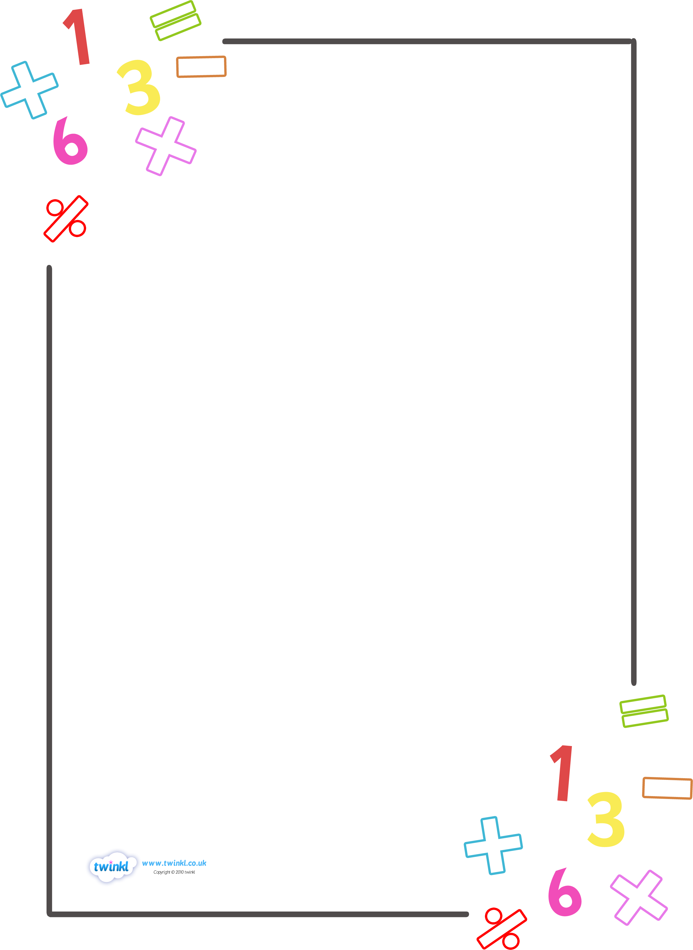

Langstone Junior

Progression
through Calculations

Year 3 and 4



Vision for Maths

All planning should be driven by the aims…

- To become fluent in the fundamentals of mathematics, through varied and frequent practise of complex problems over time so that they have the ability to recall and apply knowledge rapidly and accurately.

- Reason mathematically by following a line of enquiry, conjecturing relationships and justifying, using mathematical language.

- Can solve problems by applying their mathematics to a variety of routine and non-routine problems with increasing sophistication, including breaking down problems into simpler steps and persevering in finding solutions.

With this in mind, we have three main aims that demonstrate the focus for our school.

- We promote talk and discussion to deepen understanding and challenge new concepts.
Because…our children learn best through reflection and thinking when discussing with their peers.

- We provide choices to allow children to challenge themselves and to promote independent enquiries.
Because…we have found that our children are reluctant to independently challenge themselves and embrace the value of learning from their own mistakes and false starts. By encouraging this, we will be promoting their ability to reason and make sense of solutions.

- We develop mathematical thinking through a three part process (physical resources, visual pictures and applying this knowledge to reasoning and problem solving contexts) to embed concepts.
Because…we have found that children can apply their learning more once they have the conceptual understanding.Through this, we are developing independent thinking.
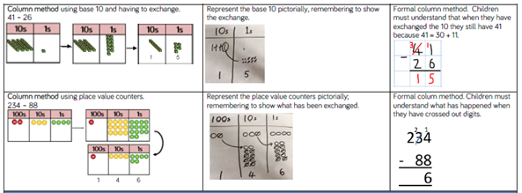
Physical Resources | Visual Representations | Abstract Numbers

PROGRESSION THROUGH CALCULATIONS FOR ADDITION

- These standards are age-related expectations and therefore we expect the majority of children to achieve them.

- Children should understand that addition is commutative and therefore calculations can be rearranged, e.g. 4 + 13 = 17 is the same as 13 + 4 = 17.

- Ensure that children understand the = sign means is the same as, not makes, and that children see calculations where the equals sign is in a different position, e.g. 3 + 2 = 5 and 5 = 3 + 2.

- Children should be encouraged to approximate before calculating and check whether their answer is reasonable.

- Children will build on their knowledge of using Base 10 equipment and place value counters continue to use this to support with the transition into a vertical method.

Different Types of Addition
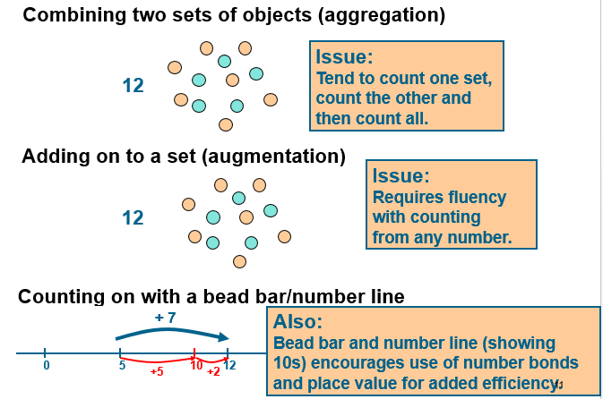

Step One: Expanded Method
This is the method for addition that comes before the column method. It helps children to understand the place value of each digit in the column method.

Children should add the least significant digits first as preparation for the compact method.

TU HTU
- 267
+ 24 + 85
11 ( 7 + 4) 12 ( 7 + 5)
80 (60 + 20) 140 (60 + 80)
91 200
352

The Base 10 equipment should be used alongside to model the transition to the vertical method but this should not be recorded by the children.

NB – number lines should still be used to aid and model mental addition however it is not an efficient written method for children to be using.

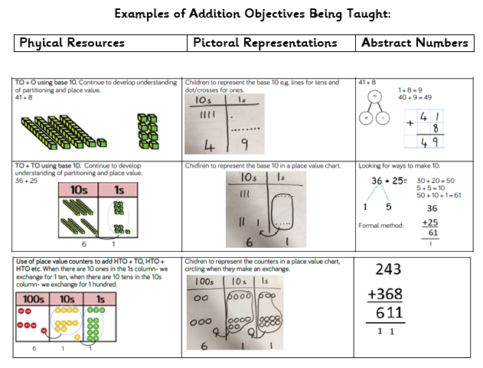

Step Two: Column Method
Based on their experiences in Y3, children will then begin to carry below the line.
The best way to model this would be using Base 10 equipment and place value counters to show how units would transfer to tens.
H
T
U
HTU
625
+ 48
673
An example of 625 + 48 using Base 10.

¹

783 367 321
+ 42 + 85 + 7
825 452 + 48
¹ ¹ ¹ 376
¹
£3.48
+ £0.78
£4.26
¹ ¹

By the end of Year 4, children will be able to use similar methods to:
- Add and subtract 1s, 10s, 100s and 1000s
- Add two 4-digit numbers – no exchange
- Add two 4-digit numbers – one exchange
- Add two 4-digit numbers – more than one exchange
- Add several numbers with different numbers of digits;
- Begin to add two or more three-digit sums of money, with or without adjustment from the pence to the pounds;know that the decimal points should line up under each other, particularly when adding or subtracting mixed amounts, e.g. £3.59 + 78p.
- Estimate answers using rounding
- Checking strategies
PROGRESSION THROUGH CALCULATIONS FOR SUBTRACTION

- These standards are age-related expectations and therefore we expect the majority of children to achieve them.

- Children should understand that subtraction is the removing or taking away one quantity from another (not necessarily the smaller number from the larger one) or finding the difference between two separate quantities.

- Children should understand that, unlike addition, subtraction is not commutative.

- Ensure that children understand the = sign means is the same as, not makes, and that children see calculations where the equals sign is in a different position, e.g. 9 – 5 = 4 and 4 = 9 – 5.

- Children should be encouraged to approximate before calculating and check whether their answer is reasonable.

Different Types of Subtraction
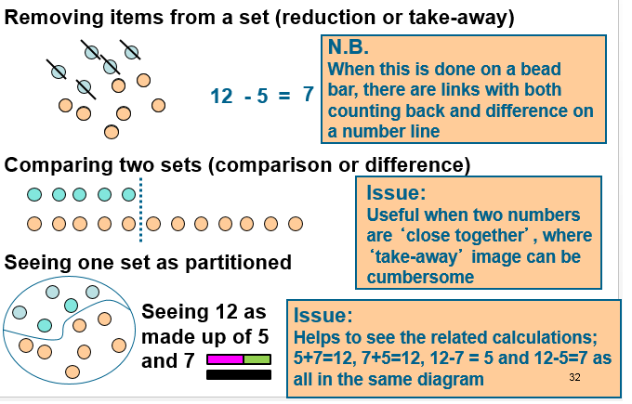

Step One: Expanded Column Not Involving Exchanging
Children should begin the method of expanded decomposition with, initially, TU – TU calculations. This process should be demonstrated using arrow cards to show the partitioning and Base 10 materials to show the decomposition of the number.
When solving the calculation 89 – 57, children need to understand that the number being subtracted (57) does not appear as an amount on its own, but rather as part of the larger amount. Therefore, when using Base 10 materials, children would need to count out only the 89.

The calculation should be read as subtract 7 from 9 or 9 subtract 7.

89 = 80 → 9
- 57 50 → 7
30 → 2 = 32

Children should use the Base 10 materials and place value counters to represent the first number and remove the units and tens as appropriate.

Initially, the children will be taught using examples that do not need the children to exchange. Emphasise that the bottom number is being subtracted from the top number rather than the smaller number from the bigger.
Step Two: Expanded Method With Exchanging

71
- 46

The calculation should be read as subtract 6 from 1 or 1 subtract 6.

Step 1 70 → 1
- 40 → 6

Children can see that they cannot subtract 6 units from the 1 unit so they need to exchange a ten for ten units. This will become:

Step 2 60 → 11
- 40 → 6
20 → 5 = 25

This would then be recorded by the children as:
₆₀
70 → ¹1
- 40 → 6
20 → 5 = 25

Children should know that units line up under units, tens under tens, and so on.

Step Three: Comparing the Expanded Method to the Column Method
754 =
- 86

Step 1 700 → 50 → 4
- 80 → 6

Step 2 700 → 40 → 14 (adjust from T to U)
- 80 → 6
Step 3 600 → 140 → 14 (adjust from H to T)
- 80 → 6
600 → 60 → 8 = 668

This would be recorded by the children as:
₆₀₀ ₁₄₀
700 → 50 → ¹4
- 80 → 6
600 → 60 → 8 = 668

When children are ready, this leads on to the compact method of decomposition:
₆₁₄ ₁
//
754
- 86
668

Subtraction as finding the difference
If the numbers involved in the calculation are close together or near to multiples of 10, 100 etc, children should be encouraged to recognise that it is more efficient to find the difference by counting up.
e.g. 511 – 197 = 314
+300
+3
+11

197 200 500 511

Help children to become more efficient with counting on by:

- Subtracting the units in one jump;
- Subtracting the tens in one jump and the units in one jump;
- Subtracting the hundreds in one jump, the tens in one jump and the units in one jump.

NB – number lines should be used to help model mental strategies of subtraction.

By the end of Year 4, children will be able to use similar methods to:
- Add and subtract 1s, 10s, 100s and 1000sSubtract two 4-digit numbers – no exchange
- Subtract two 4-digit numbers – one exchange
- Subtract two 4-digit numbers – more than one exchange
- Efficient subtraction
- Estimate answers with rounding
- Checking strategies
- Be able to subtract numbers with different numbers of digits;
- Using this method, children should also begin to find the difference between two three-digit sums of money, with or without ‘adjustment’ from the pence to the pounds;
- Know that decimal points should line up under each other.

For example:

£8.95 = 8 → 0.9 → 0.05 leading to
-£4.38 - 4 → 0.3 → 0.08 ₇ ₁
= 8 → 0.8 → 0.15 (adjust from T to U) 8.85
- 4 → 0.3 → 0.08 - 4.38
4 → 0.5 → 0.07 = £4.57

Examples of Subtraction Objectives Being Taught

PROGRESSION THROUGH CALCULATIONS FOR MULTIPLICATION

- These standards are age-related expectations and therefore we expect the majority of children to achieve them.

- Children need to understand that multiplication is commutative and use this information to rearrange calculations knowing that 4 x 6 = 24 gives the same answer as 6 x 4 = 24.

- Children need to understand that multiplication is repeated addition.

- Ensure that children understand the = sign means is the same as, not makes, and that children see calculations where the equals sign is in a different position, e.g. 3 x 5 = 15 and 15 = 3 x 5.

- Children should be encouraged to approximate before calculating and check whether their answer is reasonable.

Different Types of Multiplication
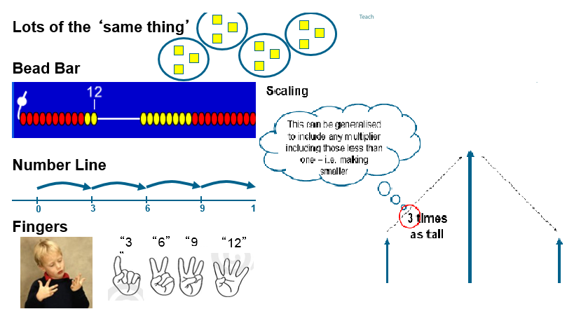

Step One: Arrays

Children should utilise multiplication as repeated addition - linked to arrays (as this knowledge will support with the development of the grid method). They should also use jottings to support their calculation.

These should be supported by the use of counters/cubes. The will need to be able to recognise 3 things: number of dots in a group, number of groups and the total. This will help relate their understanding to division.

e.g. 3 x 5 can be represented as an array in two forms (as it has commutativity):

3 + 3 + 3 + 3 + 3 = 15
5+5+5 = 15

Children should continue to utilise multiplication as repeated addition linked to arrays (as this knowledge will support with the development of the grid method) and use jottings to support their calculation. These should be supported by the use of crosses on squared paper, e.g.

7 x 4 =

x | x | x | x | x | x | x
x | x | x | x | x | x | x
x | x | x | x | x | x | x
x | x | x | x | x | x | x

7 x 4 = 4 + 4 + 4 + 4 + 4 + 4 + 4 = 28

(For mathematical accuracy the above example is actually 4 x 7 –> Four, seven times, however, because we use terms such as 'groups of' or 'lots of', children are more familiar with the initial notation. Once children understand the commutative order of multiplication the order is irrelevant).

Step Two: Moving from the Array to the Empty Array Model
Children will continue to use arrays where appropriate leading into the empty area model (an array but without the dots) of multiplication.
x 5 5 4
(6 x 5) + (6 x 5) +(6 x 4)

30
24
30
6
30 + 30 + 24

84

The empty array model does not necessarily need to be partitioned into tens and ones and neither does the array. They are methods to be used to help children to see how challenging numbers can be partitioned to make the multiplication more managaeable for them.

x 5 5 4
(6 x 5) + (6 x 5) + (6 x 4)

6
= 30 + 30 + 24

30
30
24
= 84

Step Three: The Grid Method

The grid method is different to the empty array model because it requires the child to partition the number of groups (number of rows of dots) into ones, tens and hundreds.

TU x U (Short grid multiplication – multiplication by a single digit)

23 x 8

x | 20 | 3
8 | 160 | 24 |  |  | 160
 |  |  |  |  | + 24
 |  |  |  |  | 184

HTU x U (Short grid multiplication – multiplication by a single digit)

346 x 9

x | 300 | 40 | 6
9 | 2700 | 360 | 54 |  |  | 2700
 |  |  |  |  |  | + 360
 |  |  |  |  |  | + 54
 |  |  |  |  |  | 31 1 4
¹ ¹

4.9 x 3

x | 4 | 0.9
3 | 12 | 2.7 |  |  | 12
 |  |  |  |  | + 2.7
 |  |  |  |  | 14.7
TU x TU (Long grid multiplication – multiplication by more than a single digit)

72 x 38

x | 70 | 2
30 | 2100 | 60 |  |  | 2100
8 | 560 | 16 |  |  | + 560
 |  |  |  |  | + 60
 |  |  |  |  | + 1 6
 |  |  |  |  | 2736
¹

Examples of Multiplication Objectives Being Taught

PROGRESSION THROUGH CALCULATIONS FOR DIVISION

- These standards are age-related expectations and therefore we expect the majority of children to achieve them.

- Children need to understand that division can be sharing or grouping (repeated subtraction).

- Children should understand that, unlike multiplication, division is not commutative.

- Ensure that children understand the = sign means is the same as, not makes, and that children see calculations where the equals sign is in a different position, e.g. 12 ÷ 3 = 4 and 4 = 12 ÷ 3.

- Children should be encouraged to approximate before calculating and check whether their answer is reasonable.

Step One: Division on a Number Line Subtracting One Group at a Time

Children will continue to use grouping (repeated subtraction) to represent their calculations, answering questions such as:
24 ÷ 2 =
or
There are 24 cupcakes, how many people can have 2 cupcakes each?



This should also be modelled alongside a number line to emphasise that grouping is repeated subtraction.

24
0 2 4 6 8 10 12 14 16 18 20 22
Children need to be able to decide what to do with remainders after division and round up or down accordingly. They should make sensible decisions about rounding up or down after division. For example 62 ÷ 8 is 7 remainder 6, but whether the answer should be rounded up to 8 or rounded down to 7 depends on the context.
e.g. I have 62p. Sweets are 8p each. How many can I buy?
Answer: 7 (the remaining 6p is not enough to buy another sweet)
Step Two: Division on a Number Line Subtracting More Than One Group

Before starting the more formal written method of ‘chunking’, children should first use the repeated subtraction on a vertical number line.

48 ÷ 4 = 12 (groups of 4) leading to 48 ÷ 4 = 10 (groups of 4) + 2 (groups of 4)
= 12 (groups of 4)
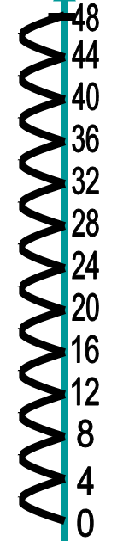
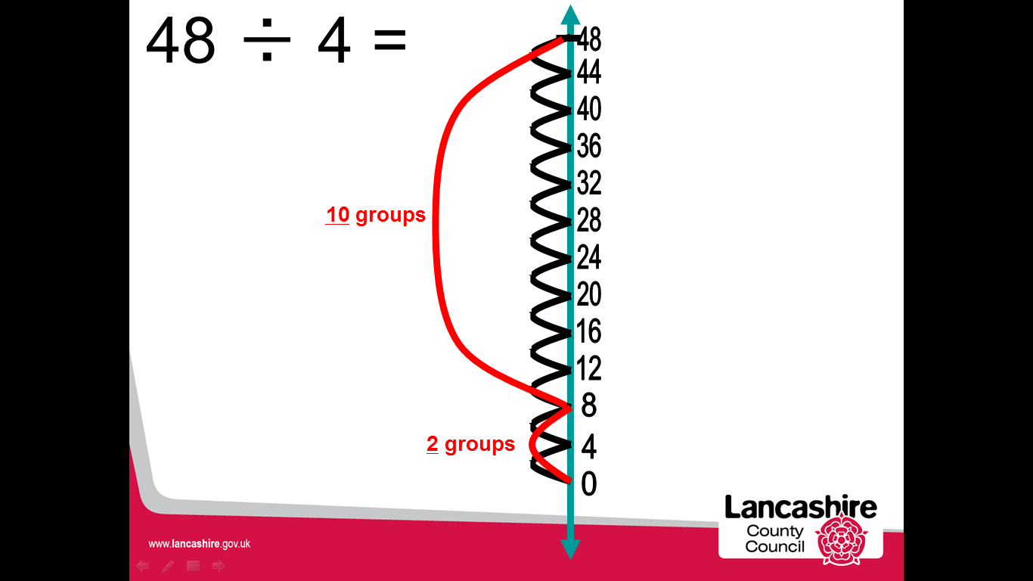

Children will develop their use of grouping (repeated subtraction) to be able to subtract multiples of the divisor, developing the use of the 'chunking' method.

Step Three: Short division - chunking (TU ÷ U)
Children should write key facts in a menu box. This will help them in identifying the largest group they can subtract in one chunk.
72 ÷ 3
24
1x 3
2x 6
5x 15
10x 30
3) 72
- 30 10x
42
- 30 10x
12
- 6 2x
6
- 6 2x
0

Answer: 24
Children should write their answer above the calculation to make it easy for them and the teacher to distinguish.
Any remainders should be shown as integers, i.e. 14 remainder 2 or 14 r 2.
Children can start to subtract larger multiples of the divisor (e.g. 20x).

Step Four: Short division - chunking (HTU ÷ U) and (HTU ÷ TU)

196 ÷ 6
1x 6
2x 12
4x 24
5x 30
10x 60
20x 120
The key facts in the menu box should be extended to include 4x and 20x.
32 r 4
6 ) 196
- 180 30x
16
- 12 2x
4

Answer: 32 remainder 4 or 32 r 4

Any remainders should be shown as integers, i.e. 14 remainder 2 or 14 r 2.

Children need to be able to decide what to do after division and round up or down accordingly. They should make sensible decisions about rounding up or down after division. For example 240 ÷ 52 is 4 remainder 32, but whether the answer should be rounded up to 5 or rounded down to 4 depends on the context.

Examples of Division Objectives Being Taught

By the end of Year 4, children will be able to use similar methods to:
- Multiply by 10, 100 and 1000
- Recall and use multiplication and division facts for multiplication tables up to 12 × 12.
- Count in multiples of 6, 7, 9. 25 and 1000
- Use place value, known and derived facts to multiply and divide mentally, including: multiplying by 0 and 1; dividing by 1; multiplying together three numbers.

